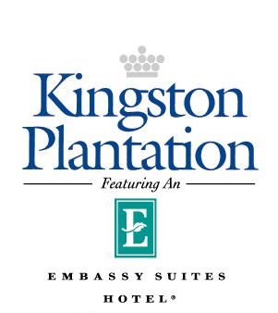

SHUTTLE SERVICE INSTRUCTIONS
In order to arrange the shuttles to and from the airport, fill out the requested information below and email by
Monday September 2, 2019: to Drew.Morgan@hilton.com
Subject Line of Email to State: Shuttle Request for HEMS Conference & Workshop (HAR)
Group Name: 13th Workshop on Harsh-Environment Mass Spectrometry
Guest Name:
Hotel Confirmation #:
Arrival Date:
Airline:
Arrival Flight #:
Arrival Flight Time:
Departure Date:
Airline:
Departure flight #:
Departure Flight Time:
Cell Phone #:
Once everyone's information is gathered the hotel will put a schedule in place for the arrivals/departures and email a confirmation of shuttle service to each attendee who registers. The round trip cost per person will be $45.00 and will be billed to the individual's guest room. For those individuals who choose not to take advantage of the hotel shuttle, the approximate cost for one way transportation from the airport is $50.00 through local taxi services at the airport.
The hotel shuttles will be parked outside baggage claim in the parking area designated for hotel shuttles. The shuttles will be marked with the Hilton logo, Kingston Plantation logo & Embassy Suites logo on each side.
The hotel will offer transportation from the Resort back to the airport starting at 7:00 am and will schedule these departures based on the information provided by those who requested round trip shuttle service. Attendees may stop by the concierge desk at any time during their stay to verify the departure time(s). If an attendee does not request service in advance, they may also sign up for a shuttle to the airport during their stay with us. These arrangements can be made through the concierge.

